1. Open the Excel file titled “macro.xlsm”. The extension “.xlsm” means the file contains macros.
2. As you are opening the file, you should be prompted with a dialog similar to the one below. Click on “Enable Macros”.

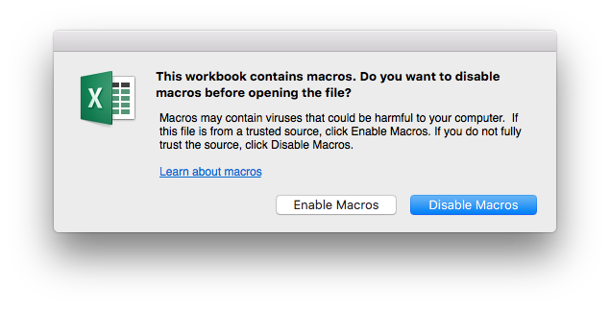

1. After you’ve opened “macro.xlsm”, open the file containing the data you wish to condense.
2. Once you’ve opened the file containing the data, add the Developer tab to the ribbon at the top of the screen by following the instructions below.

**On Mac**:

1. Press ⌘ + , (command + comma) to open Preferences.
   1. Alternatively, click on Excel in the top left-hand corner of the screen and then choose Preferences.



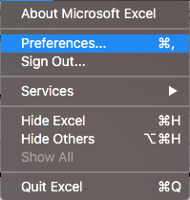

1. Open Ribbon & Toolbar.

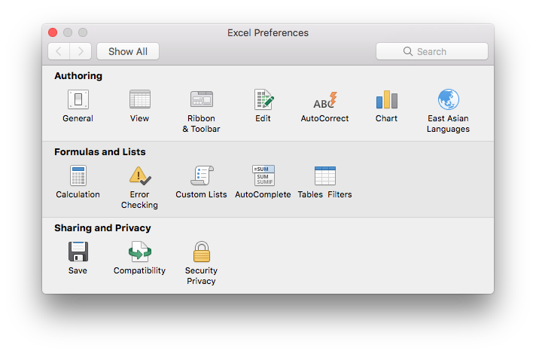

1. In the right-hand box, check the box next to Developer.

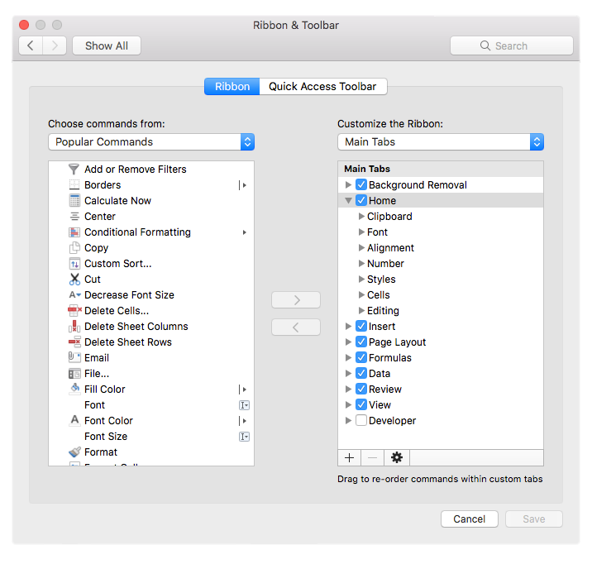

1. Click Save.

**On Windows**:

1. Click on File.
2. On the bottom of the left-hand side, click on Options.
3. Click on Customize Ribbon.
4. In the right-hand box, check the box next to Developer.
5. Click OK.
6. After adding the Developer tab, select it and click on Macros (make sure you have the tab with the data open).

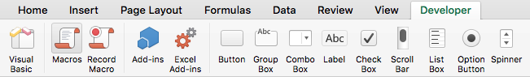

1. A window should pop up that looks like this:

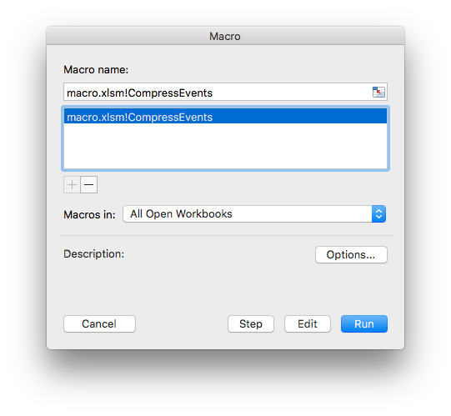

Click Run.

1. Congratulations! Your data has been condensed!